Karta 3

[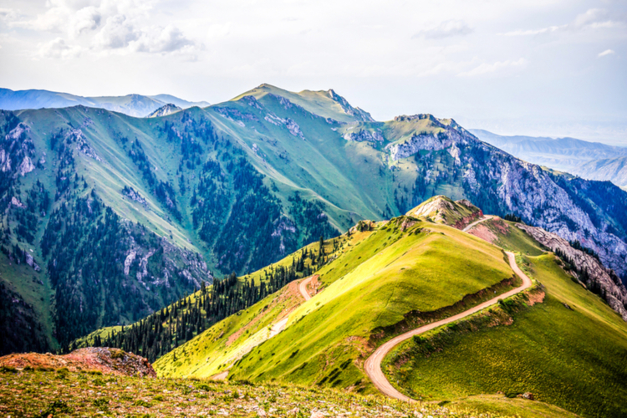](https://www.google.de/url?sa=i&url=https%3A%2F%2Fwww.chillizet.pl%2FStyl-zycia%2FSennik%2FSennik-gory-sen-o-gorach-widziec-gory-zjezdzac-z-gory-13905&psig=AOvVaw33US1e3udfNBYCglc-Zqsq&ust=1592994632426000&source=images&cd=vfe&ved=0CAIQjRxqFwoTCIDJze3dl-oCFQAAAAAdAAAAABAG)